Systemic Stress in Gold Derivatives

By Alasdair Macleod
Macleod Finance
Sunday, June 15, 2025

https://alasdairmacleod.substack.com/p/systemic-stress-in-gold-derivatives

Last month, the ECB warned of increasing counterparty risk in gold derivatives for the euro area. It has very good reason to be concerned.

Since dealers on Comex took fright at the prospects of President Trump imposing tariffs on gold and silver imports, the flood of physical gold into Comex has never been properly explained in terms of systemic risk. This article addresses this specific issue, and why it has led the ECB to conclude that gross notional exposure of gold derivatives to euro area banks and financial institutions increased by 58% between November and March.

In the May edition of its Financial Stability Review, The ECB added that a significant share of these derivatives was over the counter and not centrally cleared, leaving actors exposed to counterparty risk.
For the first time, we see a major central bank pointing out what my Substack readers will already know; and that is banks on Comex have physical delivery obligations, which is why massive quantities of gold migrated from Europe to New York. This is what the ECB said:

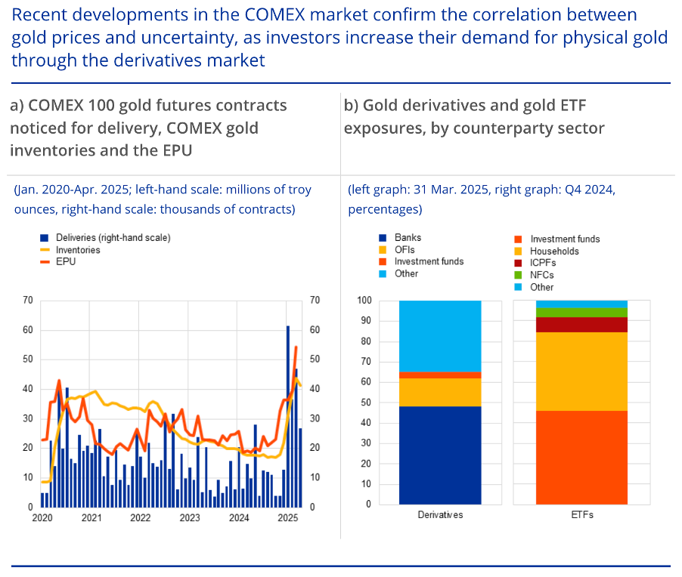

The charts are interesting too. But note the statement about “investors increasing their demand for physical gold through the derivatives market”. The next chart from MacroMicro shows how Comex warehouse stocks have fluctuated over time:
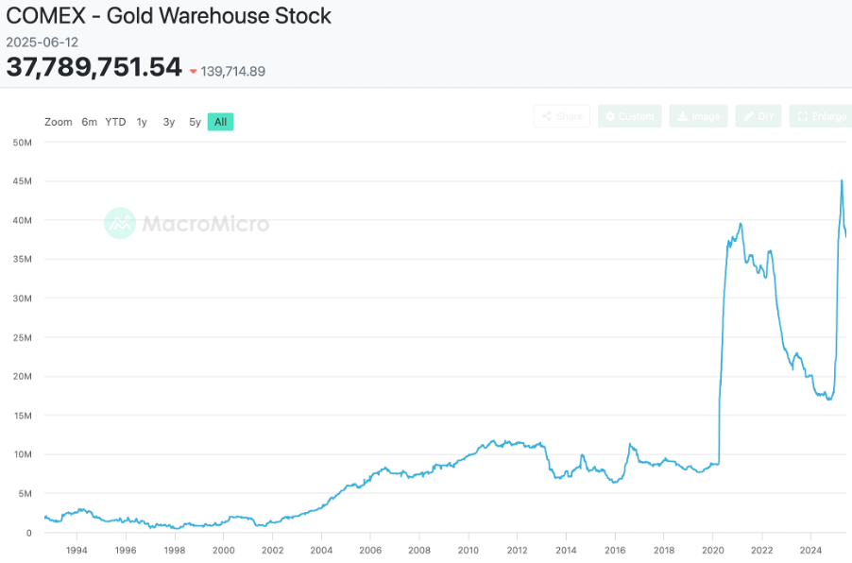
Before Comex was used as a means of obtaining physical delivery, warehouse stocks were never more than 12 million ounces. That changed on the Comex panic when stocks shot up to nearly 40moz before subsequently declining, particularly from April 2022 until last October falling to 17moz.

There were various factors leading to the decline, the most important of which was stands for delivery leading to a gradual withdrawal of bullion from Comex warehouses. This was a new feature, and from my records I estimate 67.9moz were stood for delivery over this period, contributing significantly to the net decline of 23moz in warehouse stocks.

Note that a stand for delivery does not mean that gold leaves the warehouses: it’s owner might have a warehouse receipt instead issued by the deliverer (usually a significant bullion bank), whether or not the gold is actually there. So, when Trump was elected there were likely to be backlogged delivery obligations, particularly as all of a sudden the pace of stand for deliveries increased significantly.

In other words, Comex bullion banks were being very badly squeezed on their physical positions, which is why they had to raise futures premiums to get bullion stocks up. Consequently, between November and end-March the increase in Comex warehouse stocks rose 24moz (746 tonnes), most of which came from Europe.

Banks in the Eurozone would have delivered a significant element of this gold. The 58% increase in their derivative positions almost certainly reflects purchases of forwards, futures, and options to hedge the price risk on their physical deliveries. Hence, the ECB’s increasing alarm over systemic risk, particularly in OTC obligations.

That at least is the now official narrative. The BIG point to take on board is an official recognition that stand for delivery obligations on Comex are behind the crisis. And they continue: since the November warehouse stock nadir, 26,470,000 ounces have stood for delivery, which is now partly reflected in the decline in stocks from the March peak. The pace of these deliveries is now an annualised 45moz (1,400 tonnes), a significantly higher pace than between 2021 and 2024 when the total was some 2,100 tonnes for the entire four years.

I suspect the ECB’s alarm bells were really being rung when their analysts considered the likely outcome of this saga. Eurozone banks have swapped gold for paper, and the gold is disappearing in deliveries. They sourced that gold through a mixture of their own possession, taking delivery in London through the forward market, and from the temporary ownership of leases. Now that the gold has gone or is going, how are they going to get it back?

Meanwhile, we can be sure that central banks which have been happy to provide underlying liquidity have been watching these shenanigans with high concern, realising that they might not get their gold back on lease expiry. They will be refusing to renew leases, taking away the major source of liquidity upon which the entire paper-gold system depends.

Behind the ECB’s public concern is a far deeper one. It is as close as we can get to an official warning that the gold paper game is coming to a very nasty end, likely to drive gold measured in paper currencies far, far higher.

It would be surprising if financial markets don’t wake up to this risk in the coming months. Incidentally, the same problem exists in silver, without central bank participation!

